REVISION HISTORY
Date | Version | Description | Author
15/10/2025 | 1.0 | Introduction part mostly completed. Defined the application (1.2) and abbreviations (1.3). Added references (1.4) | Arda Mutlu,Emir Gençay
21/10/2025 | 1.1 | Test descriptions for requirements T-SRS-REQ-001 to T-SRS-REQ-003 in Section 3.1 have been completed. | Arda Mutlu,Emir Gençay
22/10/2025 | 1.2 | Added spoken conventions (1.5) | Arda Mutlu, Emir Gençay
24/10/2025 | 1.3 | Completed all written sections of the document, specifically Sections 2.1, 2.2, and 2.4, ensuring clarity, accuracy, and full consistency with the Software Development Plan. | Atakan Karataş, Kayra Gökşin
28/10/2025 | 1.4 | Added all UML diagrams for Section 2.3, including the Use Case, Sequence, and Activity diagrams. All diagrams were personally created and adjusted for consistency with the written sections and the Software Development Plan. | Atakan Karataş
03/11/2025 | 1.5 | Conventions, User Requirements and System Requirements parts are updated according to the received feedback. | Arda Mutlu, Emir Gençay
04/11/2025 | 1.6 | Section 2.4 System Requirements Specification updated according to the received feedback. | Uğur Erkal
04/11/2025 | 1.7 | SRS-FOS-008 updated according to the feedback. | Kayra Gökşin
04/11/2025 | 1.8 | Section 2.3 Use Cases and Usage Scenarios updated according to the received feedback. Manager login added to the Use Case Diagram and the Activity Diagram revised with improved logical flow and controlled loops to ensure consistency and clarity. | Atakan Karataş

TABLE OF CONTENTS
1 INTRODUCTION 3
Document overview 3
System overview 3
Abbreviations 3
References 3
Conventions 4
2 REQUIREMENTS 5
2.1 User Requirements Specification 5
2.2 System Architecture 5
2.3 Use Cases and Usage Scenarios 7
2.4 System Requirements Specification 9

INTRODUCTION

Document overview

This document presents the software requirements specifications of FOS software development project. It describes functional requirements, quality requirements, constraints, use cases, and usage scenarios. It also provides an overview of the system architecture.

System overview
The Food Ordering System (FOS) is a web-based application designed to facilitate online food ordering between customers and restaurants within a unified platform. The system allows users to browse restaurant menus, customize their orders, and make secure online payments. Restaurant owners can manage menus, track orders, and update their availability in real time. The platform aims to provide a seamless and efficient experience for both customers and restaurants by automating the ordering process, reducing human error, and optimizing delivery operations. The FOS project follows the waterfall software development model and is implemented using Java-based technologies, supported by a MySQL database and a responsive frontend interface.

Abbreviations
FOS: Food Ordering System
UML:Unified Modeling Language
IDE: Integrated Development Environment
JDK: Java Development Kit
SRS: Software Requirement Specification
STP: Software Test Plan
SDD: Software Design Document
STR: Software Test Report
SDP: Software Development Plan
SAR: Software Analysis Report
SQL: Structured Query Language
ERD: Entity Relationship Diagram
JDBC: Java Database Connectivity
DDL: Data Definition Language
DML:DataManipulation Language
MVC:ModelViewController

References

# | Document Identifier | Document Title
[SDP] | FOS-SDP-v2 | “Software Development Plan of FOS Software”
[STP] | FOS-SDP-v1 | “Software Test Plan of FOS Software”

Conventions
Requirements listed in this document are constructed according to the following structure:

SRS-FOS-001
Register a new user account using an username and password.

Every system requirement ID includes the corresponding user requirement ID as a prefix.

SRS-FOS-001.1
Check that the entered username is unique and not empty.

2 REQUIREMENTS

2.1 User Requirements Specification
SRS-FOS-001
The system shall allow new users to create an account with their address, phone number, username, and password.
SRS-FOS-002
The system shall allow existing users to log in using their username and password.
SRS-FOS-003
The system shall allow users to browse restaurants and their menus, and to search or filter by restaurant name, cuisine, dish name, rating, price range, delivery time, and open or closed status.
SRS-FOS-004
The system shall allow users to add selected food items to the shopping cart, update quantities, and remove items.
SRS-FOS-005
The system shall enable users to place orders, and pay successfully.
SRS-FOS-006
The system shall allow users to rate restaurants and provide feedback.
SRS-FOS-007
The system shall allow restaurant managers to register both their personal account and their restaurant information.
SRS-FOS-008
The system shall allow restaurant managers to manage their restaurant menus by adding, editing, or deleting menu items, monitoring incoming orders, updating their restaurant availability status, and managing order workflows by canceling or changing the status of customer orders.
SRS-FOS-009
The system shall allow restaurant managers to view sales statistics, including order counts, total revenue, and customer ratings.

2.2 System Architecture
Overview
The Food Ordering System (FOS) follows a simple, layered architecture designed for clarity and ease of implementation. The project will consist of a web-based user interface, a Java application layer that handles the main logic, and a MySQL database for persistent data storage. The architecture ensures separation of responsibilities between data, application logic, and presentation while remaining lightweight for demonstration purposes.
Main Components
- User Interface (Web UI):
Developed using basic web technologies (HTML, CSS, JavaScript). It allows customers and restaurant managers to interact with the system through a browser. Users can register, log in, browse restaurants, manage their cart, place orders, and leave reviews. Managers can manage menus, view incoming orders, and access sales statistics.
- Application Layer (Java):
Contains the core functionality of the system. Each feature (registration, search, order handling, etc.) is handled by small, independent modules or classes.
Example modules include:
  - Authentication and session management
  - Restaurant and menu listing
  - Cart and order processing
  - Review and rating management
  - Manager operations and reporting
For the demo, these modules will be hosted in a single Java application using simple HTTP handlers or servlets.
- Database Layer (MySQL):
Stores all application data, including users, managers, restaurants, menu items, orders, carts, and reviews. The database ensures data consistency and supports all key operations such as login verification, order creation, and menu updates.
Data Flow Example
- The user opens the website and searches for restaurants.
- The UI sends a request to the Java application, which retrieves the matching restaurants from the MySQL database.
- The user adds items to the cart and proceeds to checkout.
- The application saves the order and updates the database.
- The manager views the new order in their dashboard.
Deployment View (Simplified)
- Node 1 – Web Browser: Displays the user and manager interfaces.
- Node 2 – Java Application Server: Processes user requests, manages sessions, and communicates with the database.
- Node 3 – MySQL Database: Stores persistent data such as users, restaurants, and orders.
Communication between the browser and the application server occurs via HTTP, while the server interacts with the MySQL database through JDBC.
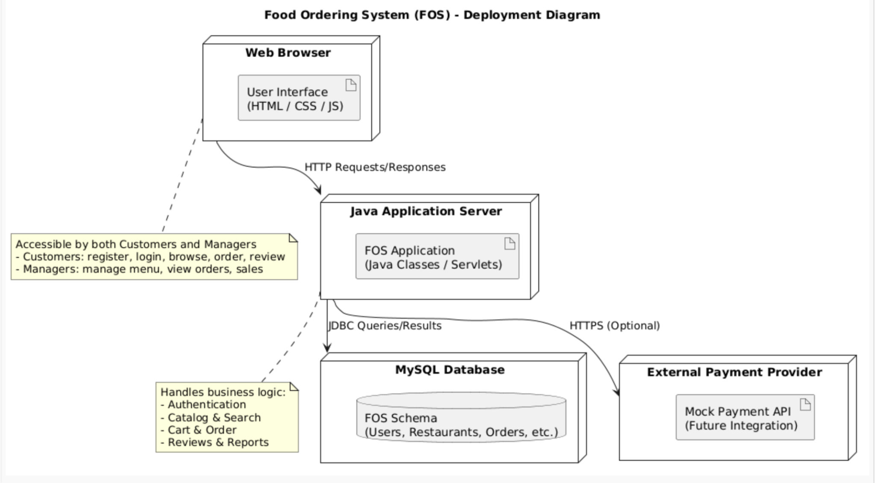
Deployment Diagram

2.3 Use Cases and Usage Scenarios
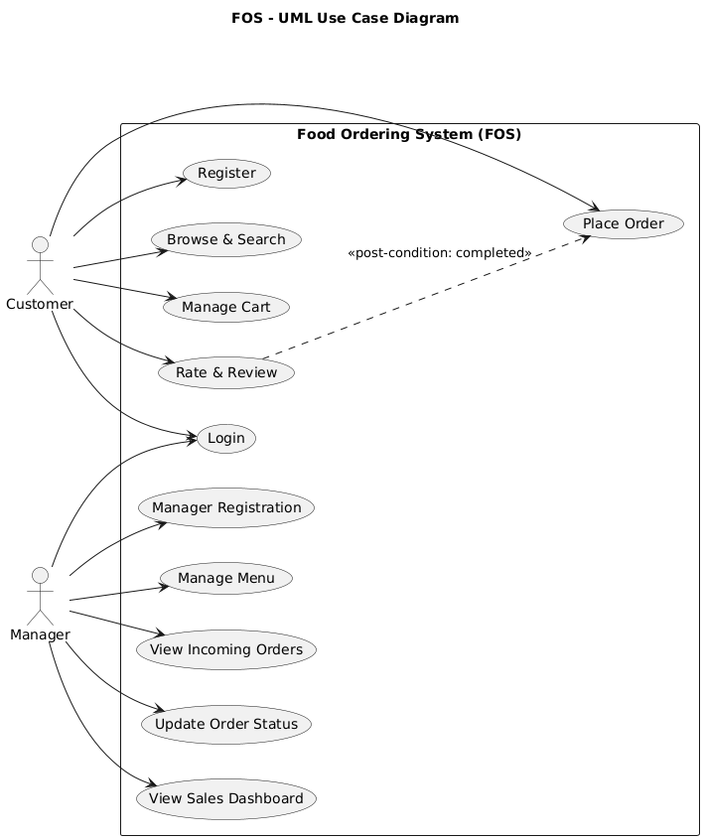
UML Use Case Diagram
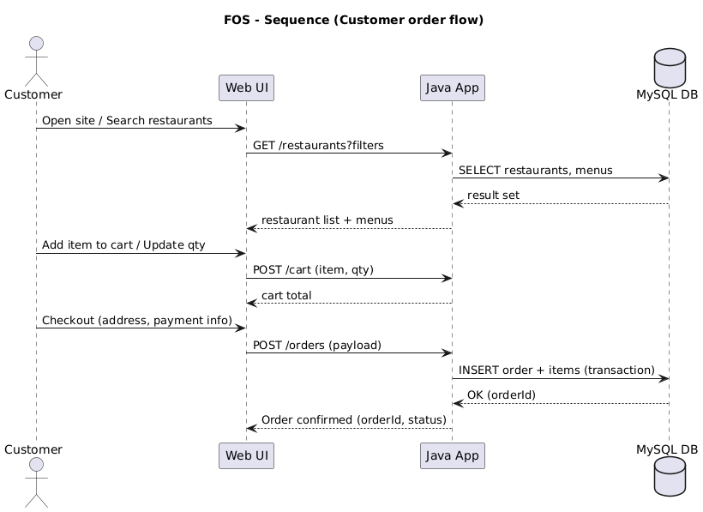
Sequence Diagram A — Customer places an order
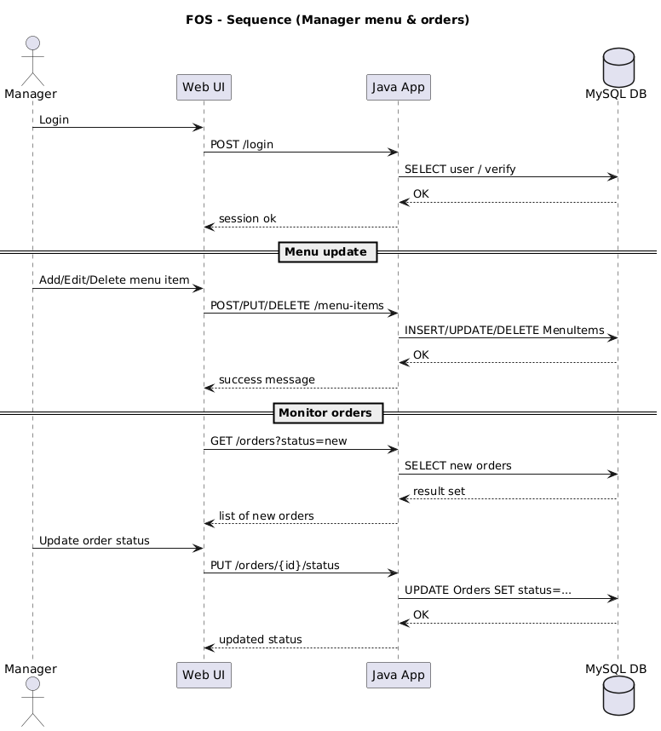
Sequence Diagram B — Manager updates menu and tracks orders
​​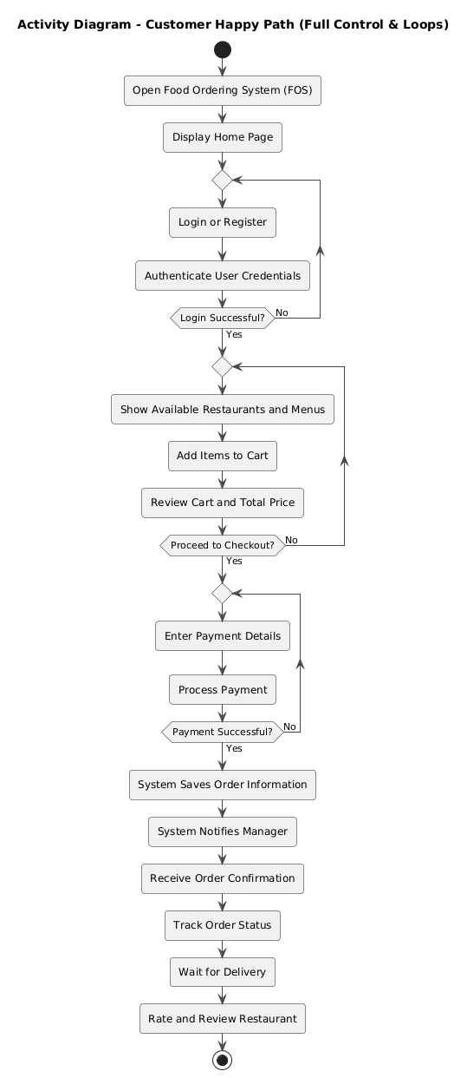
Activity Diagram — Customer happy path

2.4 System Requirements Specification

SRS-FOS-001.1
The system shall verify that the entered username is unique and not empty during registration.
SRS-FOS-001.2
The system shall store the new user’s username, password, phone number, and address information in the database.
SRS-FOS-002.1
The system shall verify user credentials during login and display an error message if authentication fails.
SRS-FOS-002.2
The system shall redirect successfully logged-in users to the home page.
SRS-FOS-003.1
The system shall list restaurants retrieved from the database with pagination and sorting options.
SRS-FOS-003.2
The system shall display the menu items belonging to a selected restaurant, including their names, prices, and availability.
SRS-FOS-003.3
The system shall present search results within 2 seconds under normal load after a user queries a restaurant or dish.
SRS-FOS-003.4
The system shall allow users to filter search results by cuisine, rating, price range, delivery time, and restaurant status (open or closed).
SRS-FOS-004.1
The system shall allow users to add, update, or remove food items from the shopping cart, but only from one restaurant at a time.
SRS-FOS-004.2
The system shall automatically calculate and display the total price of the items in the cart, including applicable taxes and fees.
SRS-FOS-005.1
The system shall save each placed order in the database, including order items, total price, and payment.
SRS-FOS-005.2
The system shall notify the user when the order status changes (e.g., preparing, on the way, delivered).
SRS-FOS-006.1
The system shall allow users to rate restaurants on a scale of 1 to 5 and provide optional textual feedback only after an order has been completed.
SRS-FOS-006.2
The system shall compute the average restaurant rating and display it on the restaurant’s profile page.
SRS-FOS-007.1
The system shall allow restaurant managers to create a personal account and link it with their restaurant record in the database.
SRS-FOS-007.2
The system shall allow managers to enter and update restaurant details such as name, address, phone, and description.
SRS-FOS-008.1
The system shall allow managers to add, edit, or delete menu items, including item name, price, category, and availability.
SRS-FOS-008.2
The system shall display all active orders for the restaurant.
SRS-FOS-009.1
The system shall generate sales statistics for each restaurant, including daily and monthly revenue and total order count.
SRS-FOS-009.2
The system shall display summarized metrics such as total income, most ordered items, and average customer rating on the manager dashboard.

